LAMPIRAN 3

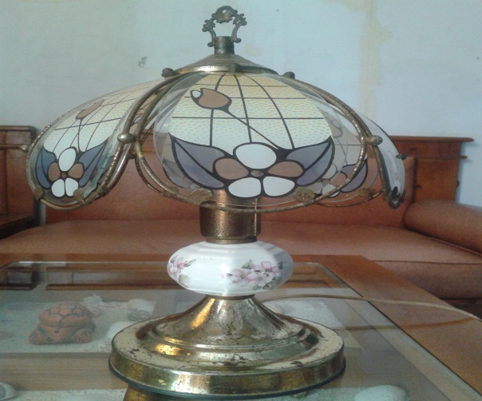
Alat Lampu Sakelar Sentuh (Touch Switch)

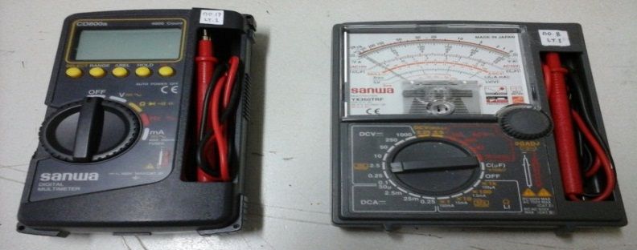
Alat Ukur Avometer Digital dan Avometer Analog

