DAFTAR PUSTAKA

Departemen Pendidikan Nasional Pusat Kesegaran Jasmani dan Rekreasi. Jakarta: 1999.
Djumidar A, Muhamad, dkk. Psikologi Olahraga. Fakultas Ilmu Keolahragaan: Jakarta
Ginanjar, Ari. Emotional spiritual quotient. jakarta : arga: 2001.
J. Cratty, Bryant. Psychology in Temporary Sport. new York: Sport science association 1973.
Lutan, Rusli. Pendidikan Kebugaran Jasmani. Jakarta: Direktorat Jendral Olahraga Depdiknas, 2001.
Lutan, Rusli dan Adang Suherman, Pengukuran dan Evaluasi Penjaskes. Jakarta: Departemen Pendidikan, 1999.
Sudjana, Nana. Penilaian Proses Belajar Mengajar. Bandung: PT Remaja Risdakarya, 1999
Sugiyono. Metodologi Penelitian Pendidikan Pendekatan Kuantitatif, Kualitatif, dan R & D. Bandung: Alfabeta, 2010.
Sujanto, Agus. Psikologi Kepribadian. Jakarta: Bumi Aksara, 2008
Setyobroto, Sudibyo. Mental Traning. Jakarta: Solo 2001
Setyobroto, Sudibyo. Psikologi Olahraraga. Anem kosong anem. Jakarta 1989.
Vealey , R. S. Sources of sport confidence : conceptualization and instrumen development. Jornal of sport and exercise psychology.
Wahyuni, Sri. Pendidikan Jasmani, Olahraga, dan Kesehatan. Jakarta: Kementrian Pendidikan Nasional 2010.

Lampiran 1

Tabel 14. Daftar hasil Kesegaran Jasmani (X1), Percaya Diri (X2), dan Hasil Belajar Pendidikan Jasmani (Y)

No. | Kesegaran Jasmani | Percaya Diri | Hasil Belajar
No. | (x1) | (x2) | (Y)
1 | 16 | 89 | 79
2 | 6 | 86 | 75
3 | 10 | 87 | 80
4 | 10 | 94 | 75
5 | 11 | 91 | 85
6 | 9 | 89 | 78
7 | 11 | 74 | 80
8 | 10 | 83 | 76
9 | 14 | 83 | 79
10 | 11 | 69 | 76
11 | 11 | 97 | 76
12 | 16 | 96 | 87
13 | 13 | 84 | 85
14 | 17 | 81 | 85
15 | 14 | 78 | 85
16 | 17 | 96 | 88
17 | 13 | 111 | 85
18 | 18 | 92 | 86
19 | 17 | 94 | 85
20 | 13 | 101 | 85
∑ | 257 | 1775 | 1630

Lampiran 2

Tabel 15. Daftar hasil Kesegaran Jasmani (X1), Percaya Diri (X2), dan Hasil Belajar Pendidikan Jasmani (Y)
No | X₁ | X₂ | Y | X₁² | X₂² | Y²
1 | 16 | 89 | 79 | 256 | 7921 | 6241
2 | 6 | 86 | 75 | 36 | 7396 | 5625
3 | 10 | 87 | 80 | 100 | 7569 | 6400
4 | 10 | 94 | 75 | 100 | 8836 | 5625
5 | 11 | 91 | 85 | 121 | 8281 | 7225
6 | 9 | 89 | 78 | 81 | 7921 | 6084
7 | 11 | 74 | 80 | 121 | 5476 | 6400
8 | 10 | 83 | 76 | 100 | 6889 | 5776
9 | 14 | 83 | 79 | 196 | 6889 | 6241
10 | 11 | 69 | 76 | 121 | 4761 | 5776
11 | 11 | 97 | 76 | 121 | 9409 | 5776
12 | 16 | 96 | 87 | 256 | 9216 | 7569
13 | 13 | 84 | 85 | 169 | 7056 | 7225
14 | 17 | 81 | 85 | 289 | 6561 | 7225
15 | 14 | 78 | 85 | 196 | 6084 | 7225
16 | 17 | 96 | 88 | 289 | 9216 | 7744
17 | 13 | 111 | 85 | 169 | 12321 | 7225
18 | 18 | 92 | 86 | 324 | 8464 | 7396
19 | 17 | 94 | 85 | 289 | 8836 | 7225
20 | 13 | 101 | 85 | 169 | 10201 | 7225
∑ | 257 | 1775 | 1630 | 3503 | 159303 | 133228
Lampiran 3
Langkah-langkah perhitungan
Perhitungan distribusi frekuensi dan T skor data mentah hasil pengukuran Kesegaran Jasmani, Percaya Diri, dan Hasil Belajar Pendidikan jasmani.
1. Kesegaran Jasmani (X₁)
a. Rentang (R)
= data terbesar – data terkecil
= 18 – 6
= 12
b. Kelas (K)
= 1 + (3,3 x log 20)
= 1 + (3,3 x 1,30)
= 5,29
≈ 5
c. Panjang kelas Interval
= R / K
= 12/5
= 2,4
d. Frekuensi Relatif
= $\frac{\text{Frekuensi} \text{Absolut}}{\text{Jumlah} \text{Percobaan}} x \text{100}\text{\%}$

e. Rata-rata (${\overline{X}}_{1}$) = $\frac{{ΣX}_{1}}{n}$
= $\frac{\text{257}}{\text{20}}$
= 12,85
f. Simpangan baku
= $\sqrt{\frac{n {ΣX}_{1}^{2}−{\left({ΣX}_{1}\right)}^{2}}{n\left(\text{n-1}\right)}}$
= $\sqrt{\frac{20 \left(\text{3503}\right)−{\left(\text{257}\right)}^{2}}{20\left(\text{20-1}\right)}}$
= $\sqrt{\frac{\text{70060}\text{.}−\text{66049}}{\text{380}}}$
= $\sqrt{\text{10,55}}$
= 3,25
g. Varians = 10,55
h. Tskor (untuk n=1)
= 50 + 10 $\left(\frac{X_{1}−{\overline{X}}_{1}}{\text{STD}}\right)$
= 50 + 10 $\left(\frac{\text{16}−\text{12,85}}{3,\text{248}}\right)$
= 59,698

2. Percaya Diri (X₂)
a. Rentang (R)
= data terbesar – data terkecil
= 111 – 69
= 42
b. Kelas (K)
= 1 + (3,3 x log 20)
= 1 + (3,3 x 1,30)
= 5, 29
≈ 5
c. Panjang kelas Interval
= R / K
= 42 / 5
= 8,4
d. Frekuensi Relatif
= $\frac{\text{Frekuensi} \text{Absolut}}{\text{Jumlah} \text{Percobaan}} x \text{100}\text{\%}$

e. Rata-rata (${\overline{X}}_{2}$) = $\frac{{ΣX}_{2}}{n}$
= $\frac{\text{1775}}{\text{20}}$
= 88,75
f. Simpangan baku
= $\sqrt{\frac{n {ΣX}_{2}^{2}−{\left({ΣX}_{2}\right)}^{2}}{n\left(\text{n-1}\right)}}$
= $\sqrt{\frac{20 \left(\text{159303}\right)−{\left(\text{1775}\right)}^{2}}{20\left(\text{20-1}\right)}}$
= $\sqrt{\frac{\text{3186060}−\text{3150625}}{\text{380}}}$
= $\sqrt{\text{93,25}}$
= 9,656
g. Varians = 93,25
h. Tskor (untuk n=1)
= 50 + 10 $\left(\frac{X_{2}−{\overline{X}}_{2}}{\text{STD}}\right)$
= 50 + 10 $\left(\frac{\text{89}−\text{88},\text{75}}{\text{93,25 }}\right)$
= 50,026

3. Hasil Belajar (Y)
a. Rentang (R)
= data terbesar – data terkecil
= 88 – 75
= 13
b. Kelas (K)
= 1 + (3,3 x log 20)
= 1 + (3,3 x 1,30 )
= 5,29
= 5
c. Panjang kelas Interval
= R / K
= 13/ 5
= 2,6
d. Frekuensi Relatif
= $\frac{\text{Frekuensi} \text{Absolut}}{\text{Jumlah} \text{Percobaan}} x \text{100}\text{\%}$

e. Rata-rata ($\overline{Y}$) = $\frac{ΣY}{n}$
= $\frac{\text{1630}}{\text{20}}$
= 81,5

f. Simpangan baku
= $\sqrt{\frac{n {ΣY}^{2}−{\left(ΣY\right)}^{2}}{n\left(\text{n-1}\right)}}$
= $\sqrt{\frac{20 \left(\text{133228}\right)−{\left(\text{1630}\right)}^{2}}{20\left(\text{20-1}\right)}}$
= $\sqrt{\frac{\text{2765820}−\text{2758921}}{\text{380}}}$
= $\sqrt{\text{18,15}}$
= 4,26
g. Varians = 18,15
h. Tskor (untuk n=1)
= 50 + 10 $\left(\frac{Y−\overline{Y}}{\text{STD}}\right)$
= 50 + 10 $\left(\frac{\text{79}−\text{81},5}{\text{18,155}}\right)$
= 48,623

Lampiran 4
Tabel 16. Data Mentah yang diubah dalam T Skor
No. | Kesegaran Jasmani |  | Percaya Diri |  | Hasil Belajar
No. | Data | T Skor | Data | T Skor | Data | T Skor
1 | 16 | 59,69 | 89 | 50,03 | 79 | 48,62
2 | 6 | 28,91 | 86 | 49,7 | 75 | 46,42
3 | 10 | 41,23 | 87 | 49,81 | 80 | 49,17
4 | 10 | 41,23 | 94 | 50,56 | 75 | 46,42
5 | 11 | 44,3 | 91 | 50,24 | 85 | 51,93
6 | 9 | 38,15 | 89 | 50,03 | 78 | 48,07
7 | 11 | 44,3 | 74 | 48,42 | 80 | 49,17
8 | 10 | 41,23 | 83 | 49,38 | 76 | 46,97
9 | 14 | 53,54 | 83 | 50,47 | 79 | 48,62
10 | 11 | 44,3 | 69 | 47,08 | 76 | 46,97
11 | 11 | 44,3 | 97 | 50,88 | 76 | 46,97
12 | 16 | 59,69 | 96 | 50,78 | 87 | 53,03
13 | 13 | 50,46 | 84 | 49,49 | 85 | 51,93
14 | 17 | 62,78 | 81 | 49,16 | 85 | 51,93
15 | 14 | 53,54 | 78 | 48,84 | 85 | 51,93
16 | 17 | 62,78 | 96 | 50,78 | 88 | 53,08
17 | 13 | 50,46 | 111 | 52,39 | 85 | 51,93
18 | 18 | 65,86 | 92 | 50,34 | 86 | 53,03
19 | 17 | 62,78 | 94 | 50,56 | 85 | 51,93
20 | 13 | 50,46 | 101 | 51,31 | 85 | 51,93

Lampiran 5
Tabel 17. Data untuk Persiapan Regresi dan Korelasi
No. | X₁ | X₂ | Y | X₁² | X₂² | Y² | X₁Y | X₂Y | X₁X₂
1 | 59,69 | 50,03 | 48,62 | 3562,9 | 2503 | 2363,904 | 2902,1 | 2432,5 | 2986,3
2 | 28,91 | 49,7 | 46,42 | 835,79 | 2470,1 | 2154,816 | 1342 | 2307,1 | 1436,8
3 | 41,23 | 49,81 | 49,17 | 1699,9 | 2481 | 2417,689 | 2027,3 | 2449,2 | 2053,7
4 | 41,23 | 50,56 | 46,42 | 1699,9 | 2556,3 | 2154,816 | 1913,9 | 2347 | 2084,6
5 | 44,3 | 50,24 | 51,93 | 1962,5 | 2524,1 | 2696,725 | 2300,5 | 2609 | 2225,6
6 | 38,15 | 50,03 | 48,07 | 1455,4 | 2503 | 2310,725 | 1833,9 | 2404,9 | 1908,6
7 | 44,3 | 48,42 | 49,17 | 1962,5 | 2344,5 | 2417,689 | 2178,2 | 2380,8 | 2145
8 | 41,23 | 49,38 | 46,97 | 1699,9 | 2438,4 | 2206,181 | 1936,6 | 2319,4 | 2035,9
9 | 53,54 | 50,47 | 48,62 | 2866,5 | 2547,2 | 2363,904 | 2603,1 | 2453,9 | 2702,2
10 | 44,3 | 47,08 | 46,97 | 1962,5 | 2216,5 | 2206,181 | 2080,8 | 2211,3 | 2085,6
11 | 44,3 | 50,88 | 46,97 | 1962,5 | 2588,8 | 2206,181 | 2080,8 | 2389,8 | 2254
12 | 59,69 | 50,78 | 53,03 | 3562,9 | 2578,6 | 2812,181 | 3165,4 | 2692,9 | 3031,1
13 | 50,46 | 49,49 | 51,93 | 2546,2 | 2449,3 | 2696,725 | 2620,4 | 2570 | 2497,3
14 | 62,78 | 49,16 | 51,93 | 3941,3 | 2416,7 | 2696,725 | 3260,2 | 2552,9 | 3086,3
15 | 53,54 | 48,84 | 51,93 | 2866,5 | 2385,3 | 2696,725 | 2780,3 | 2536,3 | 2614,9
16 | 62,78 | 50,78 | 53,08 | 3941,3 | 2578,6 | 2817,486 | 3332,4 | 2695,4 | 3188
17 | 50,46 | 52,39 | 51,93 | 2546,2 | 2744,7 | 2696,725 | 2620,4 | 2720,6 | 2643,6
18 | 65,86 | 50,34 | 53,03 | 4337,5 | 2534,1 | 2812,181 | 3492,6 | 2669,5 | 3315,4
19 | 62,78 | 50,56 | 51,93 | 3941,3 | 2556,3 | 2696,725 | 3260,2 | 2625,6 | 3174,2
20 | 50,46 | 51,31 | 51,93 | 2546,2 | 2632,7 | 2696,725 | 2620,4 | 2664,5 | 2589,1
∑ | 1000 | 1000 | 1000 | 51900 | 51900 | 51900 | 51351 | 51132 | 51158

ΣX₁ = 1000 ΣX₁² = 51900 ΣX₁Y = 51351
ΣX₂ = 1000 ΣX₂² = 51900 ΣX₂Y = 51132
ΣY = 1000 ΣY² = 51900 ΣX₁X₂ = 51158
Lampiran 6
Menghitung rata-rata dan simpangan baku T-skor
1. Kesegaran Jasmani (X₁)
Diketahui :
ΣX₁ = 1000
ΣX₁² = 51900
a. Rata-rata (${\overline{X}}_{1}$) = $\frac{{ΣX}_{1}}{n}$
= $\frac{\text{1000}}{\text{20}}$
= 50,00
b. Simpangan baku
= $\sqrt{\frac{n {ΣX}_{1}^{2}−{\left({ΣX}_{1}\right)}^{2}}{n\left(\text{n-1}\right)}}$
= $\sqrt{\frac{20 \left(\text{51900}\right)−{\left(\text{1000}\right)}^{2}}{20\left(\text{20-1}\right)}}$
= $\sqrt{\frac{\text{1038000}−\text{1000000}}{\text{380}}}$
= $\sqrt{\text{100}}$ = 10
2. Percaya Diri (X₂)
Diketahui :
ΣX₂ = 1000
ΣX₂² = 51900
a. Rata-rata (${\overline{X}}_{2}$) = $\frac{{ΣX}_{2}}{n}$
= $\frac{\text{1000}}{\text{20}}$
= 50,00
b. Simpangan baku
= $\sqrt{\frac{n {ΣX}_{2}^{2}−{\left({ΣX}_{2}\right)}^{2}}{n\left(\text{n-1}\right)}}$
= $\sqrt{\frac{\text{20} \left(\text{51900}\right)−{\left(\text{1000}\right)}^{2}}{\text{20}\left(\text{20-1}\right)}}$
= $\sqrt{\frac{\text{1038000}−\text{1000000}}{\text{380}}}$
= $\sqrt{\text{100}}$ =10

3. Kesegaran jasmani (Y)
Diketahui :
ΣY = 1000
ΣY² = 51900
a. Rata-rata ($\overline{X}$) = $\frac{ΣY}{n}$
= $\frac{\text{1000}}{\text{20}}$
= 50,00
b. Simpangan baku
= $\sqrt{\frac{n {ΣY}^{2}−{\left(ΣY\right)}^{2}}{n\left(\text{n-1}\right)}}$
= $\sqrt{\frac{20 \left(\text{51900}\right)−{\left(\text{1000}\right)}^{2}}{20\left(\text{20-1}\right)}}$
= $\sqrt{\frac{\text{1038000}−\text{1000000}}{\text{380}}}$
= $\sqrt{\text{100}}$ = 10
Lampiran 7
Perhitungan persamaan regresi
1. Regresi Y atas X₁
Diketahui
ΣX₁ = 1000 ΣX₁² = 51900 ΣX₁Y = 51351
ΣX₂ = 1000 ΣX₂² = 51900 ΣX₂Y = 51132
ΣY = 1000 ΣY² = 51900 ΣX₁X₂ = 51158
Diuraikan menjadi
a = $\frac{\left(ΣY\right)\left({ΣX}_{1^{2}}\right)−\left({ΣX}_{1}\right) \left({ΣX}_{1}Y\right)}{n {ΣX}_{1^{2}}−{\left({ΣX}_{1}\right)}^{2}}$
= $\frac{\left(\text{1000}\right)\left(\text{ 51900}\right)−\left(\text{1000}\right) \left(\text{51351}\right)}{20 \text{ 51900}−{\left(\text{1000}\right)}^{2}}$
= $\frac{\left(\text{51900}\text{000}\right)− \left(\text{51351000}\right)}{\text{1038000}−\text{1000000}}$
= $\frac{\text{549000}}{\text{38000}}$
= 14,45
b = $\frac{n \left({ΣX}_{1}Y\right)−\left({ΣX}_{1}\right) \left(ΣY\right)}{n {ΣX}_{1^{2}}−{\left({ΣX}_{1}\right)}^{2}}$
= $\frac{\left(20\right)\left(\text{51351}\right)−\left(\text{1000}\right) \left(\text{1000}\right)}{20 \text{51900}−{\left(\text{1000}\right)}^{2}}$
= $\frac{\left(\text{10}2\text{70}20\right)− \left(\text{1000000}\right)}{\text{1038000}−\text{1000000}}$
= $\frac{\text{27020}}{\text{38000}}$
= 0,71
Jadi persamaan regresi Y terhadap X₁ adalah Ŷ = 14,44 + 0,711X₁
2. Regresi Y atas X₂
Diuraikan menjadi
a = $\frac{\left(ΣY\right)\left({ΣX}_{2^{2}}\right)−\left({ΣX}_{2}\right) \left({ΣX}_{2}Y\right)}{n {ΣX}_{2^{2}}−{\left({ΣX}_{2}\right)}^{2}}$
= $\frac{\left(\text{1000}\right)\left(\text{51900}\right)−\left(\text{1000}\right) \left(\text{51}1\text{32}\right)}{20 \text{51900}−{\left(\text{1000}\right)}^{2}}$
= $\frac{\left(\text{5190}\text{0000}\right)− \left(\text{51}1\text{32000}\right)}{\text{1038000}−\text{10}\text{00000}}$
= $\frac{\text{768000}}{\text{38000}}$
= 20,21

b = $\frac{n \left({ΣX}_{2}Y\right)−\left({ΣX}_{2}\right) \left(ΣY\right)}{n {ΣX}_{2^{2}}−{\left({ΣX}_{2}\right)}^{2}}$
= $\frac{\left(20\right)\left(\text{51132}\right)−\left(\text{1000}\right) \left(\text{1000}\right)}{20 \text{51900}−{\left(\text{1000}\right)}^{2}}$
= $\frac{\left(\text{1022640}\right)− \left(\text{100}\text{0000}\right)}{\text{1038000}−\text{100}\text{0000}}$
= $\frac{\text{22640}}{\text{38000}}$
= 0,595
Jadi persamaan regresi Y terhadap X₂ adalah Ŷ = 20,21+ 0,595X₂

3. Regresi Y atas X₁ dan X₂
Dimana :
Σy² = ${ΣY}^{2}−\frac{{\left(ΣY\right)}^{2}}{n}$ = $\text{51900}−\frac{{\left(\text{1000}\right)}^{2}}{20}$ = 1900
Σx₁² = ${ΣX}_{1^{2}}−\frac{{\left({ΣX}_{1}\right)}^{2}}{n}$ = $\text{51900}−\frac{{\left(\text{1000}\right)}^{2}}{20}$ = 1900
Σx₂² = ${ΣX}_{2^{2}}−\frac{{\left({ΣX}_{2}\right)}^{2}}{n}$ = $\text{51900}−\frac{{\left(\text{1000}\right)}^{2}}{20}$ = 1900
Σx₁y = ${ΣX}_{1}Y−\frac{\left({ΣX}_{1}\right)\left(ΣY\right)}{n}$ = $\text{51351}−\frac{\left(\text{1000}\right)\left(\text{1000}\right)}{20}$ = 1351
Σx₂y = ${ΣX}_{2}Y−\frac{\left({ΣX}_{2}\right)\left(ΣY\right)}{n}$ = $51\text{13}2−\frac{\left(\text{1000}\right)\left(\text{1000}\right)}{20}$ = 1132
Σx₁x₂ = ${ΣX}_{1}X_{2}−\frac{\left({ΣX}_{2}\right)\left(ΣY\right)}{n}$ = $\text{51}\text{158}−\frac{\left(\text{1000}\right)\left(\text{1000}\right)}{20}$ = 1158
b₁ = $\frac{\left({Σx}_{1}y\right) \left({Σx}_{2^{2}}\right)−\left({Σx}_{1}x_{2}\right) \left({Σx}_{2}y\right)}{ \left({Σx}_{1^{2}}\right) \left({Σx}_{2^{2}}\right)−{\left({Σx}_{1}x_{2}\right)}^{2}}$
= $\frac{\left(1\text{35}1\right)\left(\text{1900}\right)−\left(1\text{158}\text{.}\right) \left(11\text{32}\right)}{ \left(\text{1900}\right) \left(\text{1900}\right)−{\left(1\text{158}\right)}^{2}}$
= $\frac{\left(\text{2566900}\right)− \left(\text{1310856}\right)}{ \left(\text{3610000}\right) −\left(\text{1340964}\right)}$
= $\frac{\text{1256044}}{\text{2269036}}$
= 0,55
b₂ = $\frac{\left({Σx}_{2}y\right) \left({Σx}_{1^{2}}\right)−\left({Σx}_{1}x_{2}\right) \left({Σx}_{1}y\right)}{ \left({Σx}_{1^{2}}\right) \left({Σx}_{2^{2}}\right)−{\left({Σx}_{1}x_{2}\right)}^{2}}$
= $\frac{\left(\text{1132}\right)\left(\text{1900}\right)−\left(\text{1158}\right) \left(\text{1351}\right)}{ \left(\text{1900}\right) \left(\text{1900}\right)−{\left(\text{1351}\right)}^{2}}$
= $\frac{\left(\text{2150800}\right)− \left(\text{1564458}\right)}{ \left(\text{3610000}\right) −\left(\text{1825201}\right)}$
= $\frac{\text{586342}}{ \text{1784799}}$
= 0,33

b₀ = $\overline{Y}−b_{1}{\overline{X}}_{1}−b_{2}{\overline{X}}_{2}$
= (50) – (0,625 . 50) – (0,305 . 50)
= 50 – 31,25 – $1$5, 25
= 3,5
Jadi persamaan regresi berganda Y terhadap X₁ dan X₂ adalah
Ŷ = 3,5+ 0,55X₁ + 0,33X₂
Lampiran 8
Mencari koefisien korelasi dan uji keberartian koefisien korelasi
1. Koefisien Korelasi rX₁Y
rX₁ Y = $\frac{n {ΣX}_{1}Y−\left({ΣX}_{1}\right) \left(ΣY\right)}{\sqrt{\left\{n {ΣX}_{1^{2}}−{\left({ΣX}_{1}\right)}^{2}\right\} \left\{n \text{.} {ΣY}^{2}−{\left(ΣY\right)}^{2}\right\}}}$
= $\frac{\left(20\right) \left(\text{51351}\right)−\left(\text{1000}\right) \left(\text{1000}\right)}{\sqrt{\left\{\left(20\right) \left(\text{51900}\right)−{\left(\text{1000}\right)}^{2}\right\} \left\{\left(20\right) \text{.} \left(5\text{1900}\right)−{\left(\text{1000}\right)}^{2}\right\}}}$
= $\frac{\left(\text{1027020}\right) − \left(\text{1000000}\right)}{\sqrt{\left(\text{38000}\right) \left(\text{38000}\right)}}$
= $\frac{\text{27020}}{\text{38000}}$
= 0.71

2. Uji Keberartian koefisien korelasi
t_{hitung} = $\frac{\left({\text{rX}}_{1}Y\right)\left(\sqrt{n−2}\right)}{\sqrt{1−{\left({\text{ry}}_{1}\right)}^{2}}}$
= $\frac{\left(0,\text{71}\right)\left(\sqrt{\text{20}−2}\right)}{\sqrt{1−{\left(0,\text{71}\right)}^{2}}}$
= $\frac{\left(\text{0,71}\right) \left(4,\text{242}\right)}{\sqrt{\text{0,}4}\text{96}}$
= $\frac{3,01}{0,7}$
= 4, 23
Derajat kebebasan (dk)
= n – 2
= 20 – 2
= 18
t_{tabel} = dk : 1 – ½ α
= 18 : 1 – ½ (0,05)
= 18 : 0,975
= 2,101
Berarti :
t _{tabel} dengan α = 0,05 dan dk = 18 diperoleh sebesar 2,101. Karena t_{hitung} = 4,23 > t _{tabel}, dengan demikian kita tolak H₀, berarti koefisien korelasi 0,71 adalah signifikan
3. Koefisien Korelasi rX₂Y
rX₂ Y = $\frac{n {ΣX}_{2}Y−\left({ΣX}_{2}\right) \left(ΣY\right)}{\sqrt{\left\{n {ΣX}_{2^{2}}−{\left({ΣX}_{2}\right)}^{2}\right\} \left\{n \text{.} {ΣY}^{2}−{\left(ΣY\right)}^{2}\right\}}}$
= $\frac{\left(20\right) \left(\text{51132}\right)−\left(\text{1000}\right) \left(\text{1000}\right)}{\sqrt{\left\{\left(20\right) \left(\text{51900}\right)−{\left(\text{1000}\right)}^{2}\right\} \left\{\left(20\right) \text{.} \left(5\text{1900}\right)−{\left(\text{1000}\right)}^{2}\right\}}}$
= $\frac{\left(\text{1022640}\right) − \left(\text{1000000}\right)}{\sqrt{\left(\text{38000}\right) \left(\text{38000}\right)}}$
= $\frac{\text{22640}}{\text{38000}}$
= 0.595
4. Uji Keberartian koefisien korelasi
t_{hitung} = $\frac{\left({\text{rX}}_{2}Y\right)\left(\sqrt{n−2}\right)}{\sqrt{1−{\left({\text{ry}}_{2}\right)}^{2}}}$
= $\frac{\left(0,\text{595}\right)\left(\sqrt{\text{20}−2}\right)}{\sqrt{1−{\left(0,\text{595}\right)}^{2}}}$
= $\frac{\left(\text{0,595}\right) \left(4,\text{242}\right)}{\sqrt{\text{0,646}}}$
= $\frac{2,5\text{24}}{0,\text{803}}$
= 3,143
Derajat kebebasan (dk)
= n – 2
= 20 – 2
= 18
t_{tabel} = dk : 1 – ½ α
= 28 : 1 – ½ (0,05)
= 28 : 0,975
= 2,101

Berarti :
t _{tabel} dengan α = 0,05 dan dk = 18 diperoleh sebesar 2,101. Karena t_{hitung} = 3,143 > t _{tabel}, dengan demikian kita tolak H₀, berarti koefisien korelasi 0,595 adalah signifikan

5. Koefisien Korelasi ganda ry_{1.2}
JK (Reg) = b₁ . ∑x₁y + b₂ . ∑x₂y
= (0.55 x 1351) + (0.33 x 1132)
= 743,05 + 373,6
= 1116,65

ry_{1.2} = $\sqrt{\frac{\text{JK}\left(\text{Re}g\right)}{Σy}}$
= $\sqrt{\frac{\text{1116,65}}{\text{ 1900}}}$
= $\sqrt{0\text{.}\text{587}}$
= 0.766

6. Uji Keberhasilan Koefisien Korelasi Berganda
F_{hitung} = $\frac{{{\left({\text{ry}}_{\text{12}}\right)}^{2}}/K}{{\left(1−{\left({\text{ry}}_{\text{12}}\right)}^{2}\right)}/n−2−1}$
= $\frac{{\left(0,\text{766}\right)}/2}{{\left(1−0,\text{766}\right)}/{\text{20}}−3}$
= $\frac{0\text{.}\text{383}}{0\text{.}\text{013}}$ = 29,46
Berarti F_{tabel} dengan prediktor = 2 sebagai pembilang dan (n-K-1) = 17 sebagai penyebut F_{hitung} = 29,46 > F_{tabel} (3,35) maka Koefisien korelasi berganda sebesar 0,766 adalah signifikan.

Lampiran 9
Perhitungan Uji Koefisien Determinasi

Untuk mencari seberapa besar variasi variabel Y yang ditentukan oleh variabel X, maka digunakan Uji Koefisien Determinasi dengan rumus :
KD = rx₁y² x 100%
= 0,71² x100%
= 0,5041 x 100%
= 50,41 %
Dari hasil tersebut diinterpretasikan bahwa hasil belajar ditentukan oleh kesegaran jasmani sebesar 50,41 %.
KD = rx₂y² x 100%
= 0,595² x100%
= 0,3540 x 100%
= 35,40 %
Dari hasil tersebut diinterpretasikan bahwa hasil belajar ditentukan oleh percaya diri sebesar 35,40 %.
KD = ry_{1.2} x 100%
= 0,766² x100%
= 0,586 x 100%
= 58,7 %
Dari hasil tersebut diinterpretasikan bahwa Hasil Belajar ditentukan oleh Kesegaran Jasmani dan Percaya Diri sebesar 58,7 %.

Lampiran 10
- Data Hasil Uji Coba Instrumen Percaya Diri Siswa
Tabel.18
 | Data Hasil Uji Coba Validitas Instrumen Penelitian Percaya Diri
No. | Butir soal
Resp. | 1 | 2 | 3 | 4 | 5 | 6 | 7 | 8
1 | 5 | 3 | 3 | 4 | 5 | 4 | 4 | 5
2 | 5 | 4 | 4 | 4 | 4 | 4 | 3 | 4
3 | 5 | 4 | 4 | 4 | 4 | 4 | 3 | 4
4 | 5 | 3 | 3 | 5 | 4 | 5 | 3 | 5
5 | 4 | 4 | 3 | 5 | 4 | 4 | 4 | 5
6 | 4 | 2 | 3 | 4 | 3 | 5 | 3 | 4
7 | 3 | 3 | 4 | 3 | 4 | 4 | 3 | 4
8 | 4 | 5 | 2 | 4 | 3 | 4 | 3 | 4
9 | 5 | 4 | 4 | 4 | 4 | 4 | 3 | 4
10 | 3 | 3 | 3 | 4 | 4 | 3 | 3 | 4
11 | 4 | 3 | 3 | 5 | 4 | 4 | 4 | 4
12 | 4 | 4 | 4 | 5 | 5 | 4 | 5 | 5
13 | 3 | 2 | 5 | 3 | 4 | 3 | 3 | 4
14 | 4 | 2 | 3 | 3 | 3 | 3 | 3 | 4
15 | 3 | 3 | 3 | 3 | 3 | 4 | 4 | 4
16 | 4 | 3 | 4 | 4 | 4 | 3 | 3 | 4
17 | 4 | 3 | 3 | 5 | 5 | 5 | 3 | 5
18 | 4 | 3 | 4 | 3 | 3 | 4 | 4 | 4
19 | 4 | 3 | 5 | 4 | 3 | 4 | 3 | 4
20 | 4 | 3 | 3 | 4 | 4 | 4 | 3 | 5
ΣX | 81 | 64 | 70 | 80 | 77 | 79 | 67 | 86
ΣX² | 337 | 216 | 256 | 330 | 305 | 319 | 231 | 374
r_{tabel} | 0,444 | 0,444 | 0,444 | 0,444 | 0,444 | 0,444 | 0,444 | 0,444
r_{hitung} | 0,689 | 0,311 | -0,121 | 0,753 | 0,566 | 0,549 | 0,306 | 0,608
Ket | Valid | Drop | Drop | Valid | Valid | Valid | Drop | Valid

9 | 10 | 11 | 12 | 13 | 14 | 15 | 16 | 17
5 | 2 | 4 | 3 | 4 | 4 | 5 | 5 | 4
5 | 2 | 4 | 5 | 3 | 4 | 4 | 3 | 4
5 | 2 | 4 | 5 | 3 | 4 | 4 | 3 | 4
5 | 3 | 3 | 4 | 5 | 4 | 5 | 5 | 5
5 | 4 | 4 | 4 | 2 | 4 | 5 | 5 | 5
5 | 2 | 3 | 2 | 2 | 4 | 5 | 4 | 5
4 | 3 | 4 | 3 | 4 | 3 | 4 | 3 | 2
4 | 1 | 3 | 3 | 3 | 4 | 5 | 4 | 4
5 | 2 | 3 | 3 | 4 | 4 | 4 | 2 | 2
3 | 3 | 3 | 3 | 3 | 2 | 3 | 4 | 3
5 | 4 | 5 | 5 | 4 | 5 | 5 | 5 | 4
5 | 1 | 5 | 3 | 2 | 4 | 5 | 4 | 3
5 | 2 | 3 | 3 | 2 | 4 | 5 | 4 | 4
4 | 2 | 3 | 2 | 4 | 3 | 4 | 4 | 3
4 | 4 | 4 | 4 | 2 | 3 | 4 | 4 | 4
5 | 4 | 4 | 4 | 3 | 4 | 5 | 4 | 4
5 | 1 | 4 | 3 | 2 | 4 | 5 | 5 | 5
5 | 2 | 4 | 3 | 2 | 3 | 4 | 4 | 3
5 | 3 | 4 | 4 | 1 | 3 | 5 | 4 | 4
4 | 2 | 4 | 3 | 3 | 4 | 4 | 4 | 4
93 | 49 | 75 | 69 | 58 | 74 | 90 | 80 | 76
439 | 139 | 289 | 253 | 188 | 282 | 412 | 332 | 304
0,444 | 0,444 | 0,444 | 0,444 | 0,444 | 0,444 | 0,444 | 0,444 | 0,444
0,728 | -0,122 | 0,470 | 0,398 | 0,185 | 0,790 | 0,578 | 0,373 | 0,480
Valid | Drop | Valid | Drop | Drop | Valid | Valid | Drop | Valid

18 | 19 | 20 | 21 | 22 | 23 | 24 | 25 | 26
4 | 3 | 4 | 4 | 3 | 4 | 4 | 4 | 5
3 | 2 | 5 | 3 | 4 | 4 | 4 | 4 | 5
3 | 2 | 5 | 3 | 4 | 4 | 4 | 4 | 5
3 | 3 | 5 | 3 | 3 | 3 | 4 | 4 | 5
3 | 3 | 3 | 3 | 3 | 3 | 4 | 5 | 5
3 | 3 | 4 | 4 | 3 | 2 | 4 | 5 | 4
2 | 3 | 2 | 3 | 3 | 4 | 4 | 4 | 3
3 | 3 | 3 | 3 | 3 | 3 | 4 | 4 | 4
3 | 3 | 3 | 3 | 4 | 4 | 3 | 3 | 3
2 | 2 | 2 | 2 | 3 | 2 | 3 | 3 | 3
4 | 3 | 4 | 3 | 3 | 3 | 4 | 4 | 4
3 | 4 | 4 | 2 | 4 | 5 | 4 | 5 | 5
1 | 2 | 2 | 2 | 4 | 4 | 4 | 4 | 4
3 | 3 | 3 | 3 | 3 | 4 | 3 | 3 | 4
2 | 2 | 2 | 2 | 2 | 2 | 4 | 2 | 4
3 | 3 | 3 | 3 | 3 | 4 | 4 | 4 | 5
4 | 3 | 4 | 4 | 4 | 3 | 5 | 5 | 5
4 | 4 | 3 | 3 | 5 | 4 | 4 | 4 | 5
2 | 2 | 2 | 2 | 3 | 2 | 3 | 4 | 4
4 | 3 | 3 | 3 | 3 | 3 | 4 | 4 | 4
59 | 56 | 66 | 58 | 67 | 67 | 77 | 79 | 86
187 | 164 | 238 | 176 | 233 | 239 | 301 | 323 | 380
0,444 | 0,444 | 0,444 | 0,444 | 0,444 | 0,444 | 0,444 | 0,444 | 0,444
0,665 | 0,399 | 0,811 | 0,530 | 0,282 | 0,329 | 0,574 | 0,667 | 0,724
Valid | Drop | Valid | Valid | Drop | Drop | Valid | Valid | Valid

 |  |  |  |  | Y
27 | 28 | 29 | 30 | 31 | Y
5 | 4 | 4 | 4 | 5 | 126
4 | 4 | 5 | 5 | 5 | 123
4 | 4 | 5 | 4 | 5 | 122
5 | 5 | 5 | 4 | 5 | 129
5 | 5 | 4 | 5 | 4 | 126
4 | 5 | 4 | 5 | 4 | 114
4 | 4 | 3 | 4 | 3 | 104
4 | 4 | 3 | 5 | 4 | 110
4 | 5 | 4 | 5 | 4 | 112
4 | 4 | 2 | 4 | 2 | 92
5 | 4 | 4 | 5 | 5 | 128
5 | 5 | 3 | 5 | 3 | 125
4 | 4 | 2 | 4 | 4 | 104
4 | 4 | 3 | 4 | 3 | 101
3 | 2 | 2 | 4 | 4 | 97
4 | 4 | 3 | 4 | 4 | 117
5 | 5 | 3 | 5 | 5 | 127
4 | 4 | 3 | 5 | 2 | 113
4 | 4 | 3 | 4 | 4 | 106
4 | 5 | 3 | 5 | 5 | 115
85 | 85 | 68 | 90 | 80 | 2291
367 | 371 | 248 | 410 | 338
0,444 | 0,444 | 0,444 | 0,444 | 0,444
0,78₁ | 0,534 | 0,724 | 0,436 | 0,629
Valid | Valid | Valid | Drop | Valid

Tabel. 19 Validitas Instrumen Percaya Diri
Contoh Butir No. 1
No. | X | Y | X² | Y² | XY
1 | 5 | 126 | 25 | 15876 | 630
2 | 5 | 123 | 25 | 15129 | 615
3 | 5 | 122 | 25 | 14884 | 610
4 | 5 | 129 | 25 | 16641 | 645
5 | 4 | 126 | 16 | 15876 | 504
6 | 4 | 114 | 16 | 12996 | 456
7 | 3 | 104 | 9 | 10816 | 312
8 | 4 | 110 | 16 | 12100 | 440
9 | 5 | 112 | 25 | 12544 | 560
10 | 3 | 92 | 9 | 8464 | 276
11 | 4 | 128 | 16 | 16384 | 512
12 | 4 | 125 | 16 | 15625 | 500
13 | 3 | 104 | 9 | 10816 | 312
14 | 4 | 101 | 16 | 10201 | 404
15 | 3 | 97 | 9 | 9409 | 291
16 | 4 | 117 | 16 | 13689 | 468
17 | 4 | 127 | 16 | 16129 | 508
18 | 4 | 113 | 16 | 12769 | 452
19 | 4 | 106 | 16 | 11236 | 424
20 | 4 | 115 | 16 | 13225 | 460
Jumlah | 81 | 2291 | 337 | 264809 | 9379

Diketahui :
ΣX = 81
ΣY = 2291
ΣX² = 337
ΣY² = 264809
ΣXY = 9379
= 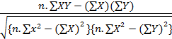

= 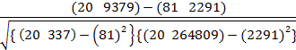

= 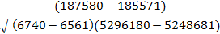

= 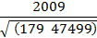

= 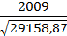

= 0,689

Dari data tersebut diperoleh r_{hitung}= 0,689 sedangkan r_{tabel} untuk n= 20 dan α = 0,05 adalah 0,444 berarti r_{hitung} > r_{tabel}, berarti data tersebut valid.

- Reabilitas Percaya Diri
Tabel. 20
No.
Resp. | 1 | 2 | 3 | 4 | 5 | 6 | 7 | 8
1 | 5 | 3 | 3 | 4 | 5 | 4 | 4 | 5
2 | 5 | 4 | 4 | 4 | 4 | 4 | 3 | 4
3 | 5 | 4 | 4 | 4 | 4 | 4 | 3 | 4
4 | 5 | 3 | 3 | 5 | 4 | 5 | 3 | 5
5 | 4 | 4 | 3 | 5 | 4 | 4 | 4 | 5
6 | 4 | 2 | 3 | 4 | 3 | 5 | 3 | 4
7 | 3 | 3 | 4 | 3 | 4 | 4 | 3 | 4
8 | 4 | 5 | 2 | 4 | 3 | 4 | 3 | 4
9 | 5 | 4 | 4 | 4 | 4 | 4 | 3 | 4
10 | 3 | 3 | 3 | 4 | 4 | 3 | 3 | 4
11 | 4 | 3 | 3 | 5 | 4 | 4 | 4 | 4
12 | 4 | 4 | 4 | 5 | 5 | 4 | 5 | 5
13 | 3 | 2 | 5 | 3 | 4 | 3 | 3 | 4
14 | 4 | 2 | 3 | 3 | 3 | 3 | 3 | 4
15 | 3 | 3 | 3 | 3 | 3 | 4 | 4 | 4
16 | 4 | 3 | 4 | 4 | 4 | 3 | 3 | 4
17 | 4 | 3 | 3 | 5 | 5 | 5 | 3 | 5
18 | 4 | 3 | 4 | 3 | 3 | 4 | 4 | 4
19 | 4 | 3 | 5 | 4 | 3 | 4 | 3 | 4
20 | 4 | 3 | 3 | 4 | 4 | 4 | 3 | 5
ΣX_{i} | 81 | 64 | 70 | 80 | 77 | 79 | 67 | 86
ΣX_{i}² | 337 | 216 | 256 | 330 | 305 | 319 | 231 | 374
σ_{b}² | 4,04 | 2,71 | 3,16 | 3,99 | 3,67 | 3,80 | 2,78 | 4,37
σ_{t}² | 399,5
r₁₁ | 0,75

9 | 10 | 11 | 12 | 13 | 14 | 15 | 16 | 17 | 18
5 | 2 | 4 | 3 | 4 | 4 | 5 | 5 | 4 | 4
5 | 2 | 4 | 5 | 3 | 4 | 4 | 3 | 4 | 3
5 | 2 | 4 | 5 | 3 | 4 | 4 | 3 | 4 | 3
5 | 3 | 3 | 4 | 5 | 4 | 5 | 5 | 5 | 3
5 | 4 | 4 | 4 | 2 | 4 | 5 | 5 | 5 | 3
5 | 2 | 3 | 2 | 2 | 4 | 5 | 4 | 5 | 3
4 | 3 | 4 | 3 | 4 | 3 | 4 | 3 | 2 | 2
4 | 1 | 3 | 3 | 3 | 4 | 5 | 4 | 4 | 3
5 | 2 | 3 | 3 | 4 | 4 | 4 | 2 | 2 | 3
3 | 3 | 3 | 3 | 3 | 2 | 3 | 4 | 3 | 2
5 | 4 | 5 | 5 | 4 | 5 | 5 | 5 | 4 | 4
5 | 1 | 5 | 3 | 2 | 4 | 5 | 4 | 3 | 3
5 | 2 | 3 | 3 | 2 | 4 | 5 | 4 | 4 | 1
4 | 2 | 3 | 2 | 4 | 3 | 4 | 4 | 3 | 3
4 | 4 | 4 | 4 | 2 | 3 | 4 | 4 | 4 | 2
5 | 4 | 4 | 4 | 3 | 4 | 5 | 4 | 4 | 3
5 | 1 | 4 | 3 | 2 | 4 | 5 | 5 | 5 | 4
5 | 2 | 4 | 3 | 2 | 3 | 4 | 4 | 3 | 4
5 | 3 | 4 | 4 | 1 | 3 | 5 | 4 | 4 | 2
4 | 2 | 4 | 3 | 3 | 4 | 4 | 4 | 4 | 4
93 | 49 | 75 | 69 | 58 | 74 | 90 | 80 | 76 | 59
439 | 139 | 289 | 253 | 188 | 282 | 412 | 332 | 304 | 187
5,16 | 1,99 | 3,47 | 3,21 | 2,56 | 3,40 | 4,86 | 4,05 | 3,80 | 2,41

19 | 20 | 21 | 22 | 23 | 24 | 25 | 26
3 | 4 | 4 | 3 | 4 | 4 | 4 | 5
2 | 5 | 3 | 4 | 4 | 4 | 4 | 5
2 | 5 | 3 | 4 | 4 | 4 | 4 | 5
3 | 5 | 3 | 3 | 3 | 4 | 4 | 5
3 | 3 | 3 | 3 | 3 | 4 | 5 | 5
3 | 4 | 4 | 3 | 2 | 4 | 5 | 4
3 | 2 | 3 | 3 | 4 | 4 | 4 | 3
3 | 3 | 3 | 3 | 3 | 4 | 4 | 4
3 | 3 | 3 | 4 | 4 | 3 | 3 | 3
2 | 2 | 2 | 3 | 2 | 3 | 3 | 3
3 | 4 | 3 | 3 | 3 | 4 | 4 | 4
4 | 4 | 2 | 4 | 5 | 4 | 5 | 5
2 | 2 | 2 | 4 | 4 | 4 | 4 | 4
3 | 3 | 3 | 3 | 4 | 3 | 3 | 4
2 | 2 | 2 | 2 | 2 | 4 | 2 | 4
3 | 3 | 3 | 3 | 4 | 4 | 4 | 5
3 | 4 | 4 | 4 | 3 | 5 | 5 | 5
4 | 3 | 3 | 5 | 4 | 4 | 4 | 5
2 | 2 | 2 | 3 | 2 | 3 | 4 | 4
3 | 3 | 3 | 3 | 3 | 4 | 4 | 4
56 | 66 | 58 | 67 | 67 | 77 | 79 | 86
164 | 238 | 176 | 233 | 239 | 301 | 323 | 380
2,03 | 3,14 | 2,18 | 2,84 | 3,04 | 3,54 | 3,93 | 4,56

 |  |  |  |  | Y | Y2
27 | 28 | 29 | 30 | 31 | Y | Y2
5 | 4 | 4 | 4 | 5 | 126 | 15876
4 | 4 | 5 | 5 | 5 | 123 | 15129
4 | 4 | 5 | 4 | 5 | 122 | 14884
5 | 5 | 5 | 4 | 5 | 129 | 16641
5 | 5 | 4 | 5 | 4 | 126 | 15876
4 | 5 | 4 | 5 | 4 | 114 | 12996
4 | 4 | 3 | 4 | 3 | 104 | 10816
4 | 4 | 3 | 5 | 4 | 110 | 12100
4 | 5 | 4 | 5 | 4 | 112 | 12544
4 | 4 | 2 | 4 | 2 | 92 | 8464
5 | 4 | 4 | 5 | 5 | 128 | 16384
5 | 5 | 3 | 5 | 3 | 125 | 15625
4 | 4 | 2 | 4 | 4 | 104 | 10816
4 | 4 | 3 | 4 | 3 | 101 | 10201
3 | 2 | 2 | 4 | 4 | 97 | 9409
4 | 4 | 3 | 4 | 4 | 117 | 13689
5 | 5 | 3 | 5 | 5 | 127 | 16129
4 | 4 | 3 | 5 | 2 | 113 | 12769
4 | 4 | 3 | 4 | 4 | 106 | 11236
4 | 5 | 3 | 5 | 5 | 115 | 13225
85 | 85 | 68 | 90 | 80 | 2291 | 264809
367 | 371 | 248 | 410 | 338
4,32 | 4,45 | 3,19 | 4,80 | 4,24 | 109,7

r11 = . 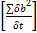
Keterangan:
r11 = reliabilitas instrument
k =banyaknya butir pernyataan atau soal
∑δb² = jumlah varians butir
∑δ = varians total
- Data Hasil Penelitian Percaya Diri Siswa

Tabel.20
Resp. | 1 | 2 | 3 | 4 | 5 | 6 | 7 | 8
1 | 5 | 4 | 5 | 4 | 5 | 5 | 4 | 4
2 | 5 | 4 | 4 | 4 | 4 | 5 | 4 | 4
3 | 5 | 4 | 4 | 4 | 4 | 5 | 4 | 4
4 | 5 | 5 | 4 | 5 | 5 | 5 | 3 | 4
5 | 4 | 5 | 4 | 4 | 5 | 5 | 4 | 4
6 | 4 | 4 | 3 | 5 | 4 | 5 | 3 | 4
7 | 3 | 3 | 4 | 4 | 4 | 4 | 4 | 3
8 | 4 | 4 | 3 | 4 | 4 | 4 | 3 | 4
9 | 5 | 4 | 4 | 4 | 4 | 5 | 3 | 4
10 | 3 | 4 | 4 | 3 | 4 | 3 | 3 | 2
11 | 4 | 5 | 4 | 4 | 4 | 5 | 5 | 5
12 | 4 | 5 | 5 | 4 | 5 | 5 | 5 | 4
13 | 3 | 3 | 4 | 3 | 4 | 5 | 3 | 4
14 | 4 | 3 | 3 | 3 | 4 | 4 | 3 | 3
15 | 3 | 3 | 3 | 4 | 4 | 4 | 4 | 3
16 | 4 | 4 | 4 | 3 | 4 | 5 | 4 | 4
17 | 4 | 5 | 5 | 5 | 5 | 5 | 4 | 4
18 | 4 | 3 | 4 | 4 | 4 | 5 | 4 | 3
19 | 5 | 4 | 4 | 4 | 4 | 5 | 4 | 3
20 | 5 | 4 | 4 | 4 | 5 | 4 | 4 | 4
ΣX | 83 | 80 | 79 | 79 | 86 | 93 | 75 | 74
ΣX² | 355 | 330 | 319 | 319 | 374 | 439 | 289 | 282
r_{tabel} | 0,444 | 0,444 | 0,444 | 0,444 | 0,444 | 0,444 | 0,444 | 0,444
r_{hitung} | 0,459 | 0,601 | 0,484 | 0,475 | 0,574 | 0,615 | 0,459 | 0,601
Ket | Valid | Valid | Valid | Valid | Valid | Valid | Valid | Valid

9 | 10 | 11 | 12 | 13 | 14 | 15 | 16 | 17 | 18
5 | 4 | 4 | 4 | 4 | 4 | 4 | 5 | 5 | 4
4 | 4 | 3 | 5 | 3 | 4 | 4 | 5 | 4 | 4
4 | 4 | 3 | 5 | 3 | 4 | 4 | 5 | 4 | 4
5 | 5 | 3 | 5 | 3 | 4 | 4 | 5 | 5 | 5
5 | 5 | 3 | 3 | 3 | 4 | 5 | 5 | 5 | 5
5 | 5 | 3 | 4 | 4 | 4 | 5 | 4 | 4 | 5
4 | 2 | 2 | 2 | 3 | 4 | 4 | 3 | 4 | 4
5 | 4 | 3 | 3 | 3 | 4 | 4 | 4 | 4 | 4
4 | 2 | 3 | 3 | 3 | 3 | 3 | 3 | 4 | 5
3 | 3 | 2 | 2 | 2 | 3 | 3 | 3 | 4 | 4
5 | 4 | 4 | 4 | 3 | 4 | 4 | 4 | 5 | 4
5 | 3 | 3 | 4 | 2 | 4 | 5 | 5 | 5 | 5
5 | 4 | 1 | 2 | 2 | 4 | 4 | 4 | 4 | 4
4 | 3 | 3 | 3 | 3 | 3 | 3 | 4 | 4 | 4
4 | 4 | 2 | 2 | 2 | 4 | 2 | 4 | 3 | 2
5 | 4 | 3 | 3 | 3 | 4 | 4 | 5 | 4 | 4
5 | 5 | 4 | 4 | 4 | 5 | 5 | 5 | 5 | 5
4 | 3 | 4 | 3 | 3 | 4 | 4 | 5 | 4 | 4
5 | 4 | 2 | 2 | 3 | 3 | 4 | 4 | 4 | 4
4 | 4 | 4 | 3 | 3 | 4 | 4 | 4 | 4 | 5
90 | 76 | 59 | 66 | 59 | 77 | 79 | 86 | 85 | 85
412 | 304 | 187 | 238 | 181 | 301 | 323 | 380 | 367 | 371
0,444 | 0,444 | 0,444 | 0,444 | 0,444 | 0,444 | 0,444 | 0,444 | 0,444 | 0,444
0,606 | 0,536 | 0,632 | 0,447 | 0,457 | 0,560 | 0,623 | 0,621 | 0,557 | 0,496
Valid | Valid | Valid | Valid | Valid | Valid | Valid | Valid | Valid | Valid

19 | 20 | Y
4 | 5 | 89
5 | 5 | 86
5 | 5 | 87
5 | 5 | 94
4 | 4 | 91
4 | 4 | 89
3 | 3 | 74
3 | 4 | 83
4 | 4 | 83
2 | 2 | 69
4 | 5 | 97
3 | 3 | 96
4 | 4 | 84
3 | 3 | 81
2 | 4 | 78
5 | 4 | 96
5 | 5 | 111
3 | 2 | 92
3 | 4 | 94
3 | 5 | 101
74 | 80 | 1775
292 | 338
0,444 | 0,444
0,510 | 0,515
Valid | Valid

- Angket Penelitian Percaya Diri
Tabel.21 Angket Percaya Diri
No | URAIAN | SS | S | RR | TS | STS
1 | Saya merasa yakin saat melakukan keterampilan gerak pada pelajaran penjas
2 | Saya mampu menerima materi penjas dengan baik
3 | Saya mampu mempraktekan gerakan yang di contohkan oleh guru
4 | Saya lamban dalam mengikuti materi pelajaran penjas
5 | Setelah beberapa kali pertemuan saya tetap tidak dapat menguasai materi penjas yang diajarkan
6 | Saya percaya dengan diri saya bahwa saya mampu jika saya terus berlatih
7 | Saya tetap tenang saat melakukan gerakan yang sulit sekalipun
8 | Saya berkonsentrasi dalam mengikuti pelajaran pendidikan jasmani
9 | Jika terus berlatih saya pasti bisa menjadi yang terbaik
10 | Saya ragu bisa mendapatkan nilai yang bagus dalam pelajaran penjas
11 | Saya suka mengulang materi yang diberikan guru pendidikan jasmani di luar jam pelajaran
12 | Saya tidak pernah mengulangi materi penjas yang diberikan baik di rumah maupun di sekolah
13 | Setelah mendapatkan materi penjas saya melatihnya kembali di luar jam pelajaran
14 | Saya pantang menyerah jika saya belum bisa menguasai salah satu materi penjas
15 | Jika saya belum menguasai salah satu materi penjas saya akan terus berusaha
16 | Saya merasa tidak dapat mengikuti materi pendidikan jasmani karena sulit
17 | Materi yang sudah diberikan harus selalu dilatih agar dapat dikuasai
18 | Materi yang sudah dikuasai harus selalu dipelajari agar lebih sempurna
19 | Materi yang sudah diberikan cukup dipelajari pada jam pelajaran penjas saja
20 | Saya pesimis bisa tampil lebih baik lagi jika sudah mengalami kegagalan

Lampiran 11
Dokumentasi pengambilan data Kesegaran Jasmani, Percaya Diri dan Hasil Belajar.

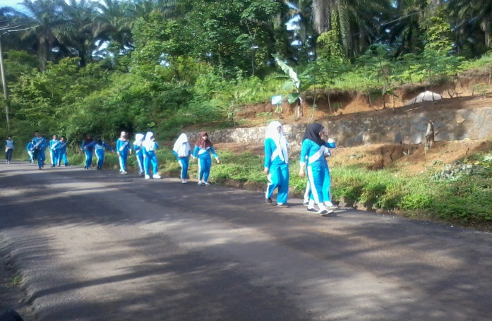
Gambar.5 Persiapan Tes Lari 60m dan 1200m

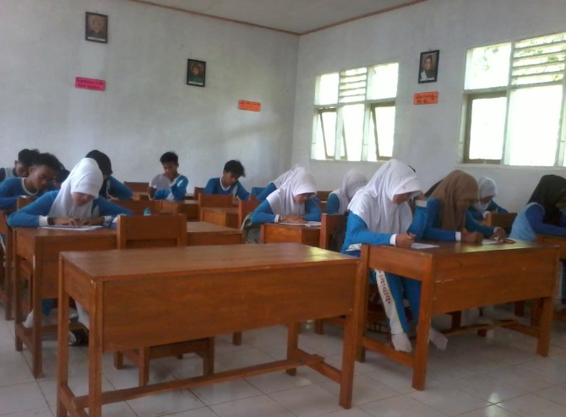
Gambar.6 Pengisian Angket Percaya Diri
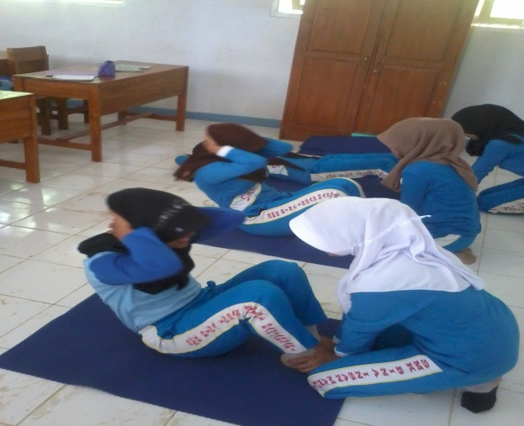

Gambar.7 Tes Baring Duduk 60 detik.

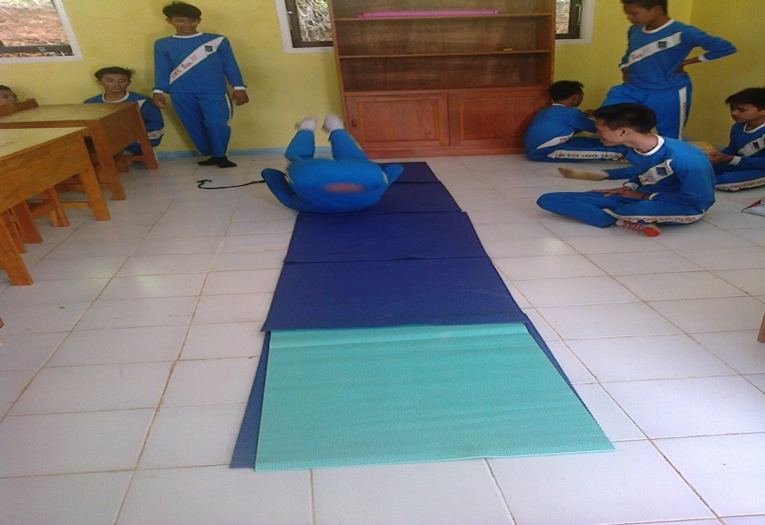
Gambar.8 Tes Hasil Belajar Materi Senam Lantai
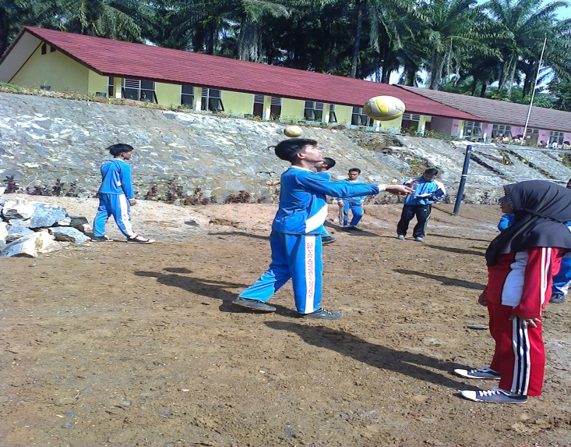
Gambar.9 Tes Bola Voley

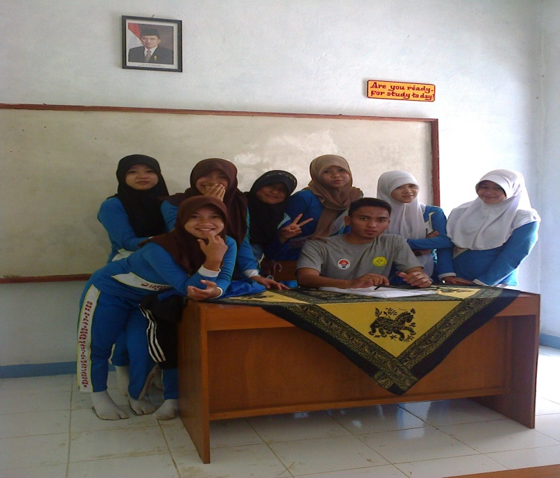

Gambar.10 Foto Bersama

